Jennifer Swinton
CS 370
Module Six Cartpole revisited

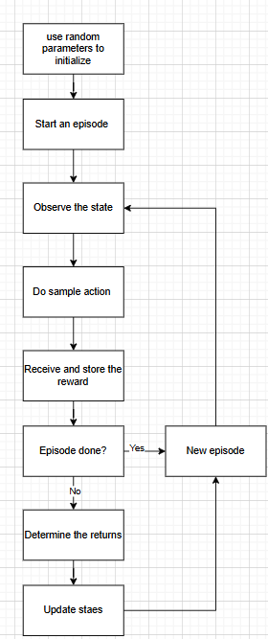
Explain how the cartpole problem can be solved using the REINFORCE algorithm.
The REINFORCE algorithm succeeds with the cartpole problem because it ‘reinforces’ actions that lead to success, or longer balancing episodes. The policy uses the Monte Carlo estimate of returns. After each episode, it increases the probability of actions that led to better balancing times by updating the policy parameters in favor of the probabilities. This way, the agent learns a stable control strategy. It directly optimizes the returns. (Yoon, 2018)

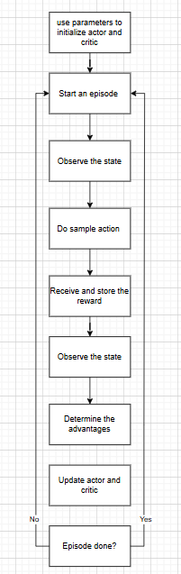
Explain how the cartpole problem can be solved using the A2C algorithm.
The A2C algorithm solves the cartpole problem in a learning method that combines policy-based and value-based approaches. The actor learns a policy to select actions, and the critic learns a value to estimate how good the value is.
The critic provides a baseline, reducing the variance of policy updates which the actor uses to update the policy (Wang, 2021). This makes the actor perform with a smoother, continuous policy. It does not need a full episode to calculate the returns.

- Explain how policy gradient approaches differ from value-based approaches, such as Q-learning.
The value-based methods approach is implicitly greedy, selecting the action with the highest estimated value. It determines this with the value function (such as the Q-function) that estimates the anticipated return by taking an action in a given state. This method learns how good an action is (Wang, 2021).
The update is a temporal-difference (TD) method that learns from estimated future values and minimizes prediction errors. The challenge for this is that it requires evaluating all actions, and the space may be endless (Wang, 2021)
The policy-gradient learns the policy directly. They learn which action to take, not the value of the action. It is defined by parameters and is differentiable. The updates directly adjust the policy and do not rely on the maximization of value. (Yoon, 2018)
- Explain how actor-critic approaches differ from value- and policy-based approaches.
The value-based algorithms learn a value function that estimates each action’s worth in a given state. It selects the action with the highest estimated value. Actor-critic runs two different methods where the actor learns a differentiable policy while the critic provides feedback, optimizing the process by blending value estimations with direct policy. The critic adds a level of function that isn’t present in the value-based approach. This allows the policy to update more often and not be dependent on full episode returns (Wang, 2021).

References

Wang, M. (2021). Understanding actor–critic methods and A2C. Towards Data Science. https://towardsdatascience.com/understanding-actor-critic-methods-931b97b6df3f
Yoon, C. (2018). Deriving policy gradients and implementing REINFORCE. Medium. https://medium.com/@thechrisyoon/deriving-policy-gradients-and-implementing-reinforce-f887949bd63

